Labour Scotland –The Future

A Discussion Paper by Alex Rowley MSP

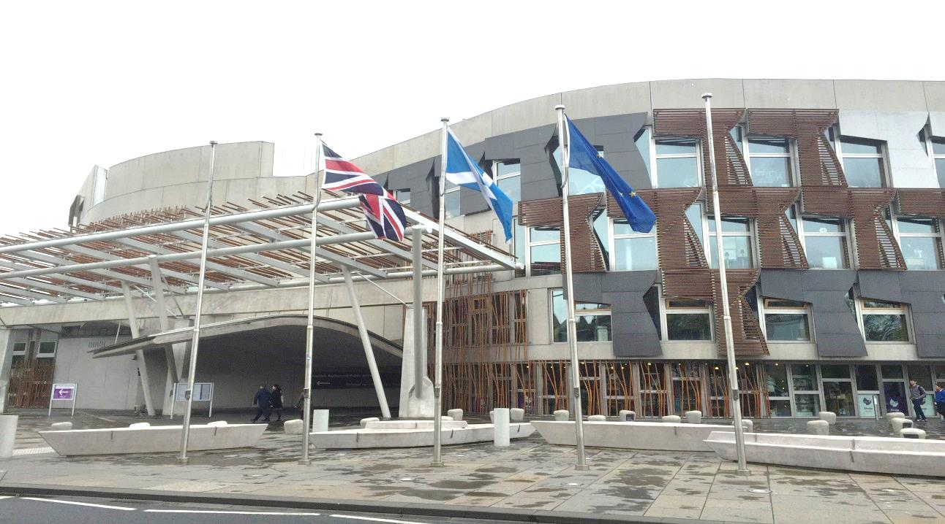

I have been a member of the Labour Party for over 32 years and was brought up in a Labour family where my Mum who died at the age of 82 had been a member since she was in her 20s and my Dad who is 85 has been a member all his adult life. My parents believed that Labour was the political voice of the Trade Unions representing the views of workers in Parliament, in Councils and in communities fighting for a better standard of living for working people.

I have never had a blind loyalty to the Labour Party but I have always understood the need for loyalty and discipline and it was therefore with great consideration that I went public last week in my call for Jim Murphy to step down as leader.

The issue for me was that with no consultation with anyone, the governing body of the Party in Scotland, the elected members of the Parliament in Scotland or with the membership, he announced he was staying to lead the party into the 2016 election. Given the scale of the defeat, I do not believe it was in the gift of him or his team, to exclusively make that call.

As I watched the results come in on the television on the Friday morning I was shocked not that there was a move away from Labour and we were getting beat, as I had spent the last few months on the doors speaking to people, but shocked by the sheer scale of the defeat. Nonetheless it was something the opinion polls were telling us for months was going to happen.

I was however clear in my mind that there should be no knee jerk reaction to such a defeat; we needed a full and honest discussion and a fundamental review of both strategy and practice within the Labour Party. I was also very clear that this defeat was not and could not be allowed to become just a question about leadership as it is clear that the problems we face as a Party are much wider and deeper. However the strategy that had been followed by the leadership was in my mind an issue that needed to be reviewed. I also question what had happened from the major review in 2011 that was led by Jim Murphy when we lost so badly in the Scottish Parliament elections. We could not just say the strategy was sound but that we did not have an enough time to turn things around as this was not strictly true. In truth we bounced from focus group to focus group making policies up as we went along with no real clarity of what Labour in Scotland actually stood for.

We needed then, as we need now, a proper analysis of where we are and what is wrong as people in Scotland in their hundreds of thousands who had voted Labour all their lives felt they could no longer do so. Every party member that knocked doors of people they knew must have experienced it, that almost sinking feeling where someone could not look you straight in the eye, and would talk about anything but their vote, or the person who says to you ‘I am sorry but Labour has lost its way’. Our role on that Friday morning and in the weeks ahead is it seems to me is to understand what happened and why.

Since the election results there have been many who have commented and offered analysis and some have already put forward what they see as solutions. Dave Watson of Unison has put forward a very interesting analysis which can be found at http://unisondave.blogspot.co.uk and I do agree with the point he makes that ‘careful consideration is needed before offering solutions’.

For my part I am arguing that a many people in communities across Scotland where Labour has enjoyed widespread support have now lost faith and trust that Labour in Scotland speaks for them.

Following the referendum in September I wrote a paper http://www.alexrowley.org/moving-fortward-discussion-paper-on-the-future-of-the-scottish-labour-party and argued that there was a need for a fundamental root and branch review of policy direction and that this could not be dominated by a group of Labour MPs in Westminster, a National Executive Committee (Labour’s governing body) for whom Scotland makes up 8.4% of the UK population and a UK leadership that has no remit over a wide range of social and economic policy in Scotland. I stated that it was clear that these groups who were still the dominant force within Scottish Labour were very out of touch with Scottish opinion on the direction of devolution and I cited as an example Labour's timid devolution proposals which were eventually agreed after much disagreement within the Party at the different levels.

To be blunt the Labour Party in Scotland has over a number of years been chasing rather than setting the agenda and this has left us in a position where we looked at best out of touch but worse a party that puts its self-interest before that of the people it seeks to serve.

This was absolutely the case in terms of the referendum where we had many MPs who were not willing to concede any further powers from Westminster to Edinburgh arguing that there was not any support at Westminster for Scotland unilaterally getting further devolution without changes to current constitutional and financial arrangements. They maintained the choice in September was between ‘separation and the settled system of devolution’.

I became weary at the amount of times I was told from other politicians that their mail bags were not full of people raising constitutional issues and this was not the issue on the doorsteps. This belief was prevalent within much of the parts that made up and had influence over policy and direction of Scottish Labour, and hence resulted in the complete failure of Labour in Scotland to lead the way with a progressive agenda for further devolution in Scotland.

It is of course a fact that the decline of Scottish Labour did not happen overnight and it was not just our complete failure to recognise the mood for more powers to come from Westminster to Edinburgh that led to the worst result ever for Labour in Scotland last week. Nor was it just the catastrophic decision to line up with the Tories to say we are ‘better together’ which left so many Labour supporters confused as to what Labour actually did stand for. The decline had been consistent over a number of years and was perhaps disguised to an extent by the 2010 general election result which seemed to back the view widely expressed by Labour MPs and others that the cream of Labour talent sat in Westminster and in Edinburgh we had a pretty poor calibre of MSP which was why we were doing badly in the Scottish general elections. In essence this was simply all down to the talent pool.

Personally I have never signed up to that view and I am inclined to lean more towards ‘all of the above’ and in particular the lack of a more progressive agenda that addressed the big issues in our communities leading us to seem more and more out of touch with the very people we sought to serve. I read this week with real concern a briefing against MSPs in one national newspaper describing some as third rate candidates and being attributed to a senior Labour source. The key point here must be there is no longer any room in the Labour Party for such sources and the stuff of student politics briefing and counter briefing. If they have something to say then put their name to it otherwise they should take their vile politics elsewhere as this is the politics of the past and has no place in a modern Scottish Labour Party.

|  |  |  |  |
| --- | --- | --- | --- |
| **Scottish Labour vote & seats in all Elections in Scotland Since 1997.** | | | |
|  | | | |
| **Election Year** | **Labour MSP's / MP's** | **Vote share percentage\*** |  |
|  |  |  |
| **UK 1997** | **56** | **45.60%** |
| **SP 1999** | **56** | **36.23%** |
| **UK 2001** | **56** | **43.90%** |
| **SP 2003** | **50** | **31.95%** |
| **UK 2005\*** | **41** | **39.50%** | **\* New boundaries reduced seats from 72 to 59.** |
| **SP 2007** | **46** | **30.70%** |  |
| **UK 2010** | **41** | **42.00%** |
| **SP2011** | **37** | **29.00%** |
| **UK 2015** | **1** | **24.30%** |
|  | | | |
| **Key: SP = Scottish Parliament Election I UK= United Kingdom General Election**  **\* For the purpose of comparison the list and constituency votes in all Scottish Parliament elections have been averaged.** | | | |

As a rough comparison if the general election result were to be applied to the 2016 Scottish election the outcome would result in Labour losing every constituency seat and 7 MSP’s overall, (we now have 38 as we got a gain in the Dunfermline by-election) resulting in another SNP Government with an overwhelming majority.

Even with a disastrous low of 24% of the vote the PR system would be kinder to us than first past the post and we would get somewhere in the region of 31 list seats based on what happened last week. Interestingly the SNP would have somewhere in the region of 74 seats. The other factors not taken into account here is that the Greens and perhaps others may well do a lot better on the list at the Scottish election so 31 seats for Labour may well be being very ambitious at this juncture.

This means that many within Labour who have their sights set on the Scottish Parliament will now be keen to get themselves onto Labour’s list. I do not however believe this to be a very good survival strategy for Labour and if it is the case that by May 2016 we have not been able to progress back from the current all-time low it is my view we will just sink even lower. So some may well save their careers for a wee bit longer but actually the party will not survive.

So what to do? The analysis will continue and in Fife local CLP’s are meeting and Fife Labour is putting in place a discussion day in June for all members with facilitators and discussion groups so that all members who wish to come along can do so, have their say and make a contribution to the debate. As mentioned there are many different blogs that are all worth a read, some from people on the left, the right and those who would describe themselves as more progressives than being ideologically tagged to left or right. However I am sure you all agree that it is a time to be completely honest about where we are if Labour is to come back stronger,

**The ‘Branch Office’ of UK Labour question**

Some in Labour were rather annoyed about Johann Lamont’s comment last year about the UK Party and its leadership treating Scottish Labour as the branch office and I have heard many say this is not a description they recognise.

I am afraid I do recognise this description and believe it must be addressed in order for Labour Scotland to move forward with a more progressive approach that sets the future agenda for Scotland. Those who do not want to address this issue and have avoided doing so to date tend to argue that tinkering with the structures is not going to solve the issue facing Scottish Labour.

I should say I want to move much beyond simply tinkering with the structures and believe we need to learn the lessons from sister parties elsewhere across Europe where there is strong federal system of government in place. We also must rebuild a Party in Scotland that encourages openness and debate where people feel free to express their views and work within the structure to influence the policy.

The irony is it was Labour who delivered devolution, delivered our Parliament in Scotland and yet it is Labour that has struggled most when it comes to devolving the decision making powers within our Party to Scotland. Even within the Party in England there must now surely be a recognition that Scotland is more than just a region of the UK and there must also be a realisation that it was the fear of nationalism hyped up not by the SNP but by a desperate and unscrupulous Tory Party in England that cost Labour many seats across 'middle England' and this was undeniably a major contributor to the Tories being back in power. Indeed, I would go as far as to say that the greatest threat to the future of the UK at this moment in time is the fact we have in Downing Street a British Prime Minister who is there as a result of a focussed anti-Scottish campaign targeted at middle England hyping up English nationalism.

So whilst in itself how our Party in Scotland is organised and governed will not address many of the key issues around strategy and practice, it is crucial that we here in Scotland take a far greater degree of control of the policy and decision making processes whilst remaining committed to remaining part of a wider UK Party where it is appropriate to be so. But as a Party of Home Rule for Scotland our starting point to Westminster and to the UK Labour Party must be that the current relationship between Scotland and the rest of the UK is untenable and will require radical change.

There are a number of questions being posed just now by the outgoing Scottish leader including one member one vote (OMOV), opening up selections for next year’s elections and the relationship with the UK Party. Most people would agree the system we have now for electing leaders is a bit antiquated so OMOV I assume will be widely supported, with regards to selections this should involve a discussion with the constituency parties and the relationship with the UK Party we must address in an open and transparent dialogue.

**Strategy and Practice**

For me defining what Labour Scotland stands for is key to defining our strategy and practice as we move forward. In my view Labour exists to advance the social and economic case of working people across the country through an agenda that puts fairness and equality at its heart ensuring that every child no matter what family they are born into is given the chance to achieve to their full potential.

I grew up in a mining village in the late 60s and early 70s where as a child there was no central heating in our houses and most had coal fires but our parents were able to speak about the achievements from when they were kids like getting an inside toilet and a bath. In those days it was clearer what Labour was fighting for in terms of better housing, better wages, better terms and conditions. The majority of people were in work, people did not live as long in many cases due to industrial disease, to living in damp conditions and to poorer life styles and life chances. There were very few people who had cars and I remember the first colour TV in our street and the excitement that caused as we knocked the door of the family to ask to see their telly.

You could argue that modern day life today bears no resemblance to 40 years ago but interestingly inequality within communities seem greater today, the housing waiting lists are larger, the levels of unemployment and benefit claimants are greater, social dysfunction/breakdown was not common then but today is more prevalent and for many people who are in work life is very difficult with people struggling to make ends meet. I would say that the difference from when I grew up in Kelty to today is that most people were in the same boat, people did not have much when it came to material wealth but it was the norm to have a job, to struggle, to get by and to live in communities where there was a real sense of community and collectivism.

Today our communities are more diverse and range from deep rooted social deprivation amongst some individuals and families through to those working hard and struggling to get by from week to week and to those who are doing well having got a higher level of education, securing good employment and enjoying a good standard of living.

For all these people the message of change, of something better, in a sense the message of 1997 - 'things can only get better' - was appealing and why not? Add to that the deep distrust of politicians or in particular distrust of the established political elites and why indeed would you not vote for something different?

I have rarely in my lifetime met parents and grandparents who did not have total aspiration for their kids. And Labour must demonstrate in Scotland that we are the party of aspiration for all Scotland’s children with a new approach that will drive up educational opportunity and achievement for every child to achieve their potential through policies yes in the playgroups, the nurseries, the schools and colleges but also policies that drive ambition through all spheres of Scottish life. However the word aspiration which is getting banded around at the moment doesn't and shouldn't just apply to individuals or families but the type of society we want to be.

As I have talked to hundreds of people on their doorsteps over this last months while I was never able to quite put my finger on any specific policies and say if only we do this or we change that I eventually drew the conclusion it was not about one policy or another it was more widespread change in approach and in strategy.

The damage of the expenses scandals of Westminster cannot be understated, it came up time and time again on the doorsteps and although there is no party in Scotland that has not been tainted by the greed of their representatives, it did feel like Labour was seen as the villains in Scotland. So recognition of the lasting damage the expenses scandal did and openness and transparency for politicians pay and expenses is a must.

And, Labour must fundamentally move its approach to one that focusses on issues and solutions that we represent as opposed to focussing on what other parties do. Labour exists not to oppose the SNP but to put forward a progressive agenda for Scotland that will address the issues in our communities and bring about a more inclusive and prosperous country where everyone is able to share in the rewards of a sustainable and successful economy.

The attack style politics is not working, people have shut off not just from Labour’s approach but from Labour.

Where we can work with the SNP, such as finding a long-term solution to funding local government then we should and where we think their approach will be damaging such as ending the Barnett formula then we should make the case. Where we believe that the SNP are not delivering as they should, given they have been in power in Edinburgh for eight years, we must put forward our alternative not simply attack their failure. Take education as an example, we do need to do much better if we are to tackle the unacceptable levels of inequality in our society and I believe with all sincerity that the SNP government is letting young people down and failing miserably, but that is not my starting point for it is so negative. My starting point is to put forward a programme, a vision and the funding necessary for local education authorities to deliver the educational outcomes our young people and our country require. It is to develop a policy agenda that will put education in Scotland at the top of education achievement in Europe.

In Fife Labour have managed to prioritise funding and target that funding where required at local schools with excellent results. I want to build on this by getting more resources and power to the local level, to the educationalists, to the school and to the classroom.

<http://www.thecourier.co.uk/news/local/fife/fife-schools-record-breaking-literacy-work-attracting-national-interest-1.875350>

On the constitution we must move away from the politics of fear to the politics of hope and ambition through further devolution setting out the positive case for ‘Home Rule’ what that means and how we will use the powers both in Edinburgh and in London to deliver our vision and our strategy for a more fair, more just Scotland where everyone has the chance to succeed to their full potential and where our country plays its part within the UK and across the world.

We must build a radical and progressive movement for change in Scotland that embraces devolution, progresses localism and delivers fairness. We must also encourage open debate and discussion whether that is the renewal of Trident, the role of the welfare state and how to build a fairer more equal society - Labour in Scotland must reflect the views of members and the communities we seek to serve and we will do that by engaging in an open and transparent approach rebuilding the trust that once made Labour the ‘Workers Party’ and put us at the heart of every community across Scotland.